TLS Certificate Expiry Checker
Summary: A C++ program that checks whether a website’s TLS certificate is expired. It uses the OpenSSL command-line program to obtain a website’s certificate information and determine if the certificate is expired.

Key Features:
- Accepts any website URL a user enters
- Retrieves a website’s certificate expiry information using the OpenSSL command-line program
- Extracts the website’s expiry date and compares it to the current date
- Displays whether the certificate is expired or not

How it works:
- An OpenSSL command is passed to the terminal to retrieve certificate details:
openssl s_client -servername " + website + " -connect "+ website+":443 < NUL 2>&1 | openssl x509 -noout -dates

- The output of the OpenSSL command is stored in a string using the popen function.
- The date string following “notAfter” is extracted using the find and substr functions.
- The date string is converted into a tm struct using istringstream and the get_time function.
- The difference between the certificate’s expiry date and the current date is calculated and the certificate’s status is output to the screen.

Key Libraries Used:
<iostream> - for input/ouput operations such as cout
<cstdlib> - to use the system function to execute system commands
<memory> - to use the unique_ptr to save input from popen
<sstream> - to allow the certificate date string to be converted into a tm struct

Example usage:
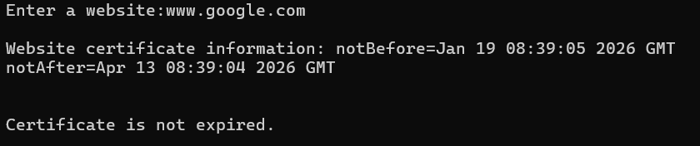
Figure 1: Output showing TLS certificate validity check for google.com

